Take the Agilent Infiniium 9000 Series Scope Challenge
If you’re like most engineers, you never know what your next project will demand from you. That means you need a scope that can adapt to your ever-changing debug and test challenges. If you tend to purchase your scopes from the same vendor every time, or if it’s been a while since you’ve taken a look at what today’s oscilloscopes can do, you might be surprised at the capabilities you can have at your fingertips. Take the Agilent mid-range (600 MHz to 4 GHz bandwidth) scope challenge and see how your current scope compares.
Just follow these easy steps:
Step 1: View a 5-minute Web Tutorial
Step 2: Tell us what you think (Please note: this step is optional. You do not have to host the survey)

Ready to get started? Click here to complete Step 1: View a 5 minute web tutorial.

9000 Series Scope Challenge Step 1: View a 5-minute Web tutorial
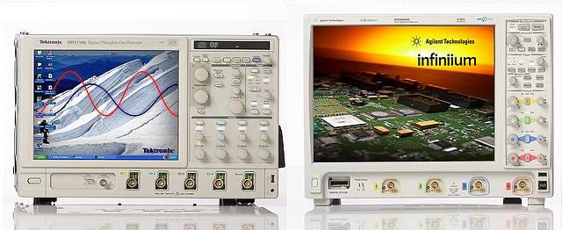
Agilent Infiniium 9000 Series Oscilloscope
Tektronix DPO7000 Series Oscilloscope

We’ve chosen the Tektronix DPO7000 series scopes for our comparison since they’ve been around for quite some time and many people are familiar with them. While the two scopes have comparable price tags, that’s where the similarity ends. We’ve engineered the Agilent Infiniium 9000 Series oscilloscopes to give you the broadest measurement capability available today.
Agilent gives you a unique form factor that fits your lab environment so you can use your scope where you need it.
We engineered a dense 20-layer printed circuit board technology and advanced ASIC and FPGA designs and packaged it vertically to produce the thinnest, lightest and most portable scope in its class and give you the biggest display available.
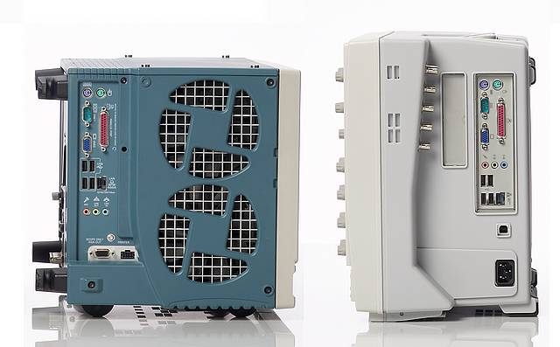
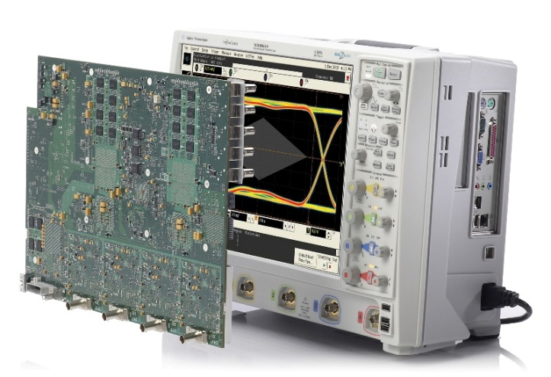

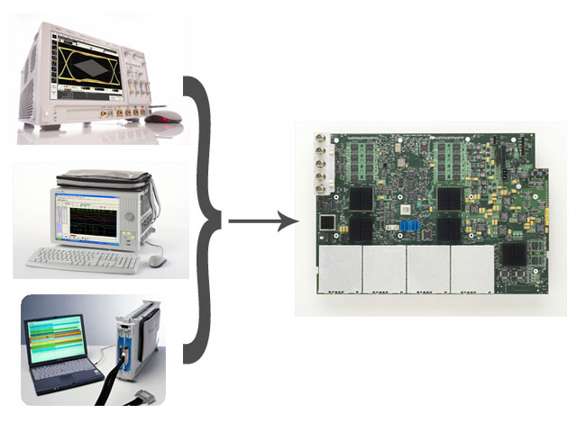
Agilent gives you three instruments in one so you can make most key digital debug measurements without scrambling to find another box.

- We start with a world class scope.
Specifications: At 4 GHz true analog bandwidth, the Agilent scope outperforms the Tek. While both scopes ship with 10 Mpts of memory standard, Agilent’s architecture maintains up to 400 times faster deep memory update rates while Tek’s performance degrades, substantially impeding responsiveness. With up to 500 Megapoints of memory across all channels on the Agilent scope, you can capture longer periods of time.
Usability: Making automated measurements? Agilent’s intuitive usability enables one step drag & drop operation versus multiple clicks through pull down menus for Tek to do the same risetime measurement.
Functionality: When traditional hardware triggering isn’t sufficient, Agilent’s InfiniiScan Event Identification software provides unmatched functionality with 8 qualified triggering zones.
OSCILLOSCOPE COMPARISON
 | Tektronix DPO7000 Series | Agilent Infiniium 9000 Series
Bandwidth | 3.5 GHz (Software Boosted) | 4 GHz True Analog
Memory | 50 Mpts 4 ch, 200 Mpts max | 500 Mpts 4 ch, 1 Gpts max
Update Rate (10 Mpts) | 0.5 waveforms/sec | 190 waveforms/sec
Drag and Drop Measurements | NO | YES
InfiniiScan Software Triggering | NO | YES

- We add the timing analysis capability of a logic analyzer.
Only Agilent offers Mixed Signal Oscilloscopes to capture and view 4 analog channels of acquisition along with 16 integrated logic analysis timing channels. Get accurate analysis of timing relationships between control signals and data buses.
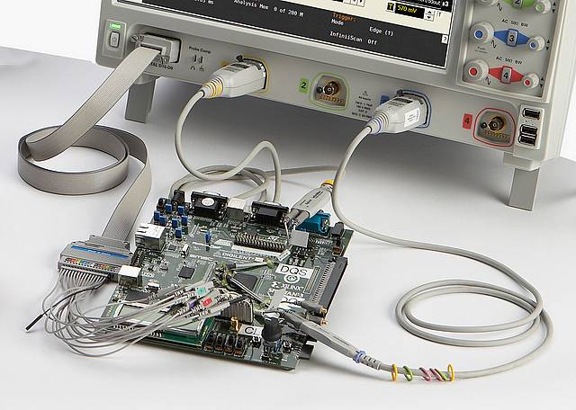

Agilent’s MSO-based FPGA dynamic probe application allows you to quickly import signal names from your design environment and move between banks of internal FPGA signals without recompiling your design for fast and efficient debug.

From data sheet p.5

LOGIC SUPPORT COMPARISON

 | Tektronix DPO7000 Series | Agilent Infiniium 9000 Series
16 digital channels | NO | 2 GSa/s
FPGA software | NO | Xilinx, Altera
Bus display | NO | YES

- We top it off with the packet views of a protocol analyzer.
With Agilent scopes, get time correlated physical and protocol views without finding and hooking up a protocol analyzer. Our protocol analysis tools are fully integrated into the scope, while Tek’s offering often requires running separate applications. You can go from waveforms on screen to protocol decode in just seconds using auto setup on the Agilent scope.
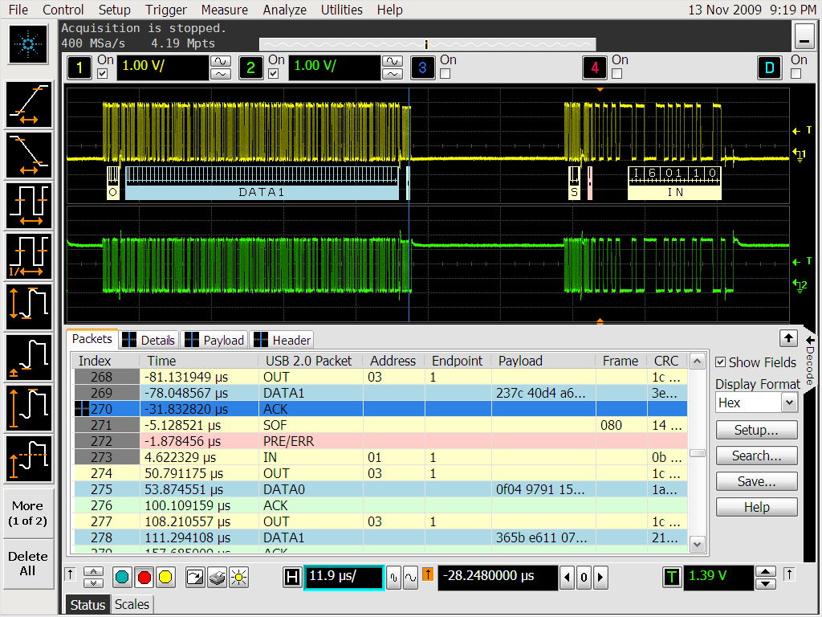
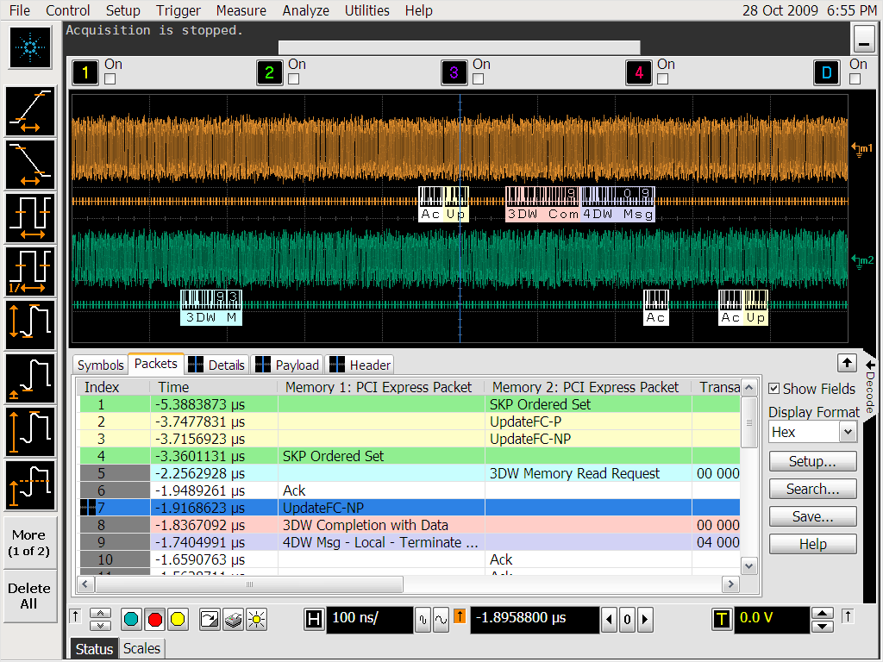

Agilent is the only scope to offer multi-tab protocol viewing, making it easy to see additional protocol information. And we support almost twice as many protocols as Tek

Header tab shows packets in a databook format. Hovering on any tab reveals additional detail.
Payload tab shows data carried by packet in byte-by-byte HEX and ASCII
Details tab breaks the packets into easy-to-read textual fields

PROTOCOL SUPPORT COMPARISON
 | Tektronix DPO7000 Series | Agilent Infiniium 9000 Series
Fully integrated in scope | SOMETIMES | YES
Auto Setup | NO | YES
Multitab viewer | NO | YES
Time aligned marker | NO | YES
Supported Protocols | I2C, SPI, RS-232, CAN, LIN, FlexRay | I2C, SPI, RS-232, CAN, LIN, FlexRay, USB 2.0, MIPI-DPhy, SATA, PCIe, 8B/10B

And Agilent gives you the widest range of software packages in the industry to make sure you can put the power of three instruments in one to work for you.

You’ve completed step 1of the Agilent Infiniium 9000 Series scope challenge. We hope you’ll choose to put the power of three instruments in one to work for you with your next scope purchase!
Click here to go to Step 2: Tell us what you think and register to win a FREE 1000 Series Oscilloscope

Thank you for taking the Agilent Infiniium 9000 Series scope challenge. (Please note: this step is optional. You do not have to host the survey)

Which of the following features not available on the Tektronix DPO7000 series scopes would you find most useful on your next scope?
- Serial protocol support for USB 2.0, MIPI-DPhy, SATA, PCI Express, or 8B/10B
- 16 channels of logic timing analysis
- FPGA debug tools
- 500 Mpts of memory per channel
- InfiniiScan zone-qualified triggering for hard-to-define using traditional scope trigger
- Drag and drop measurement capability for ease of use
- Multitab protocol viewing
Then add all standard questions and PAB from other challenges
What brand of scope do you use most often today? *
Agilent
LeCroy
Tektronix
Other
If other, please specify
Will you consider an Agilent scope for your next purchase? *
I would have considered Agilent prior to taking the scope challenge
This scope challenge experience has convinced me to consider Agilent next time
These capabilities give me no reason to add Agilent to my consideration list
Tell us what you think.
Do you have a need for any of Agilent’s 9000 Series Scopes?
Yes
No
What is your timeframe for purchasing any of the products selected above?
0 to 3 months
4 to 12 months
13 to 24 months
> 24 months
Unknown
What is your budget status?
Approved
In process
Plan to request
Plan to lease
None
Unknown

