Take the Scope Challenge.
Is your scope up to the challenge? The next 5 minutes might surprise you.
See for yourself.
Just follow these 3 easy steps.
Step 1: Watch a two-minute video
Step 2: Read a quick explanation of why what you saw is true
Step 3: Tell us what you think (Please note: this step is optional. You do not have to host the survey)
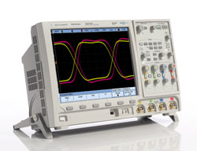
Ready to get started? Click here to watch the video

Take the Scope Challenge Step 2

How can what you just saw be true?
We showed you a real example comparing the Tek MSO4054 and the Agilent MSO7054 probing a signal with an intermittent glitch (occurring about 25 times a second). Results would be similar on all other scopes in this class from all vendors because Agilent’s waveform update rates are up to 1,000 times faster than anyone else’s. The first question most people ask us when we show them the difference is “Why doesn’t everyone just increase their update rates, then?”

Engineered for the best signal visibility
If it were simple, of course they WOULD. Agilent has invested in custom IC technology to deliver a lot of functionality in a single chip. Display memory, waveform plotting, memory controller and acquisition memory capabilities that lose precious time in chip-to-chip communication in other architectures are all incorporated into the blazing fast MegaZoom III IC’s that are the heart of our InfiniiVision scopes. We’ve literally engineered our scopes to give you the best signal visibility available today.
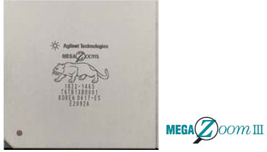

Unmatched display quality
Capturing those random and infrequent events that can wreak such havoc in your designs is clearly the most critical reason that fast waveform update rates are desirable. But it stands to reason that the faster you’re updating the screen, the more signal information you’ll see on the screen at the same time. Agilent’s InfiniiVision scopes offer unmatched display quality and signal representation.
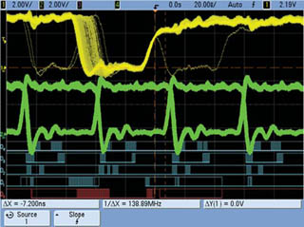

Responsive deep memory
This final bonus from fast waveform update rates may not be as intuitively obvious. If you’ve ever had the experience of turning deep memory on and having your scope’s responsiveness to controls slow dramatically, you were also a victim of slow update rates. Most vendors compensate for this by defaulting to shallow memory and forcing you to think about when you want it turned on. Agilent InfiniiVision scopes optimize for the deepest memory available on each measurement so you’re always getting the most signal visibility possible.
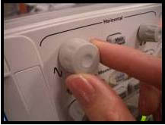

Take the Scope Challenge Step 3: Feedback Form (Please note: this step is optional. You do not have to host the survey)

Tell us what you think about the challenge.
* Asterisk indicates required field.
Will you consider an Agilent scope for your next purchase? *
I would have considered Agilent prior to taking the scope challenge
This scope challenge experience has convinced me to consider Agilent next time
These capabilities give me no reason to add Agilent to my consideration list
Tell us what you think. (free form for comments)
Do you have a need for any of Agilent’s 7000 Series Scopes?
Yes
No
What is your timeframe for purchasing any of the products selected above?
0 to 3 months
4 to 12 months
13 to 24 months
> 24 months
Unknown
What is your budget status?
Approved
In process
Plan to request
None
Unknown

